**AWS PROJECT – Two Tier Architecture (for Approval)**

**Client :XXXXXXXXXX**

**Create and Install Wordpress in AWS EC2 with RDS  
  
Scope of the Project:** (Project with Default VPC)

#**1. Sync Dev & Prod Databases via S3 Service**

**#2. Domain Based Routing**

**#3. The End Client / User Should Access the website only using https not with http.**

**#4. Create Dashboard in Cloud Watch (Custom Meter)**

**#5. Memory Utilization- Monitor Using Cloud Watch**

**#6. Purchase and implement Certification for the Domain**.

**APPLICATION FLOW**

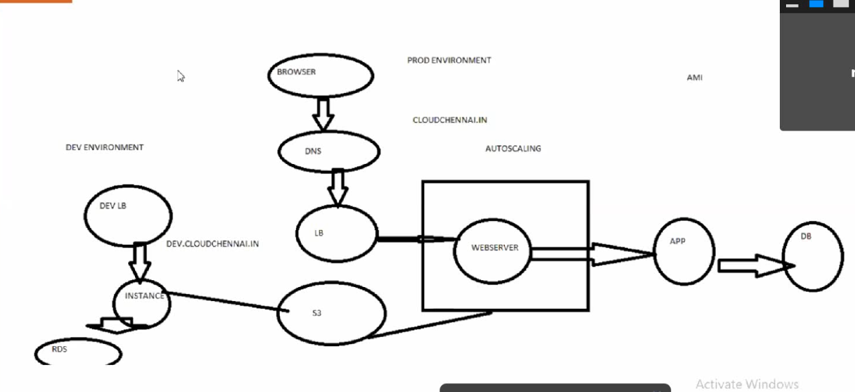

**Step#1 . Service ROUTE53 – DNS Connectivity with Domain**

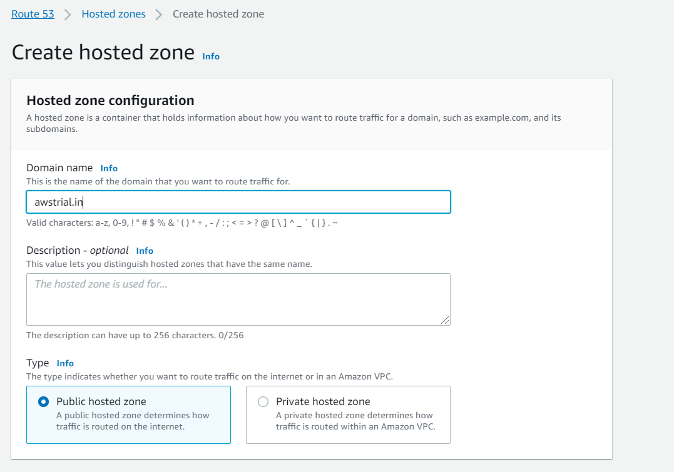

Name Servers Updated to Domain

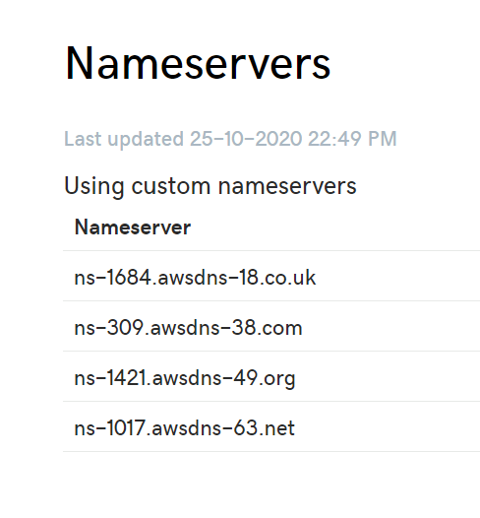

**Step#2 . Service:Amazon Certificate Manager (ACM)**

Getting Certificate for Domain

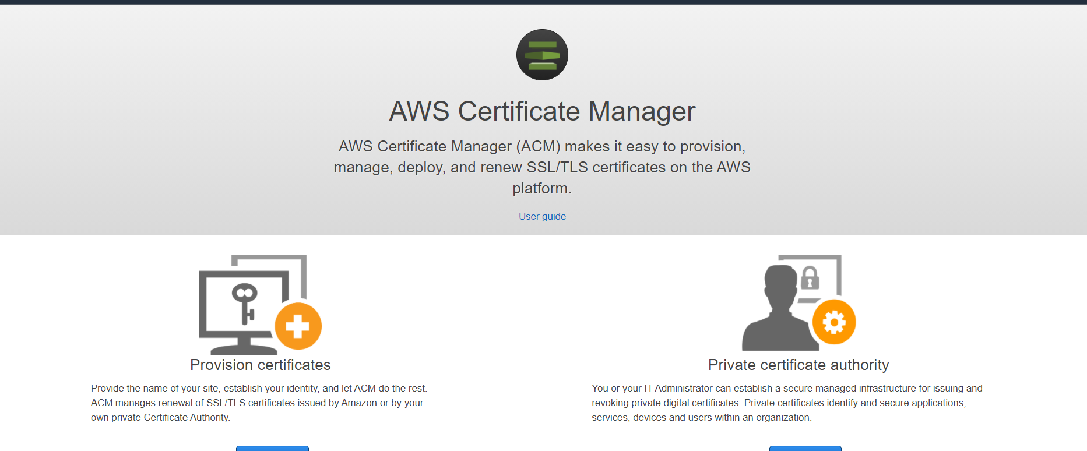

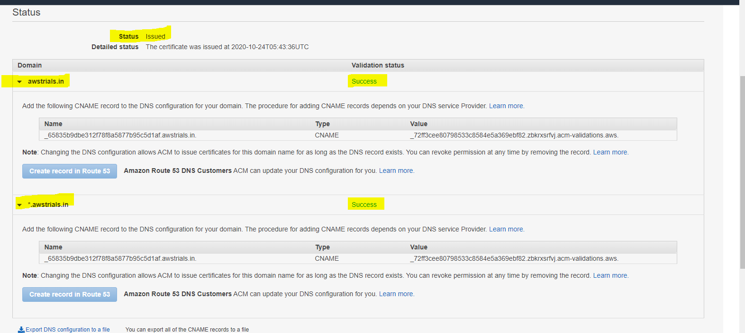

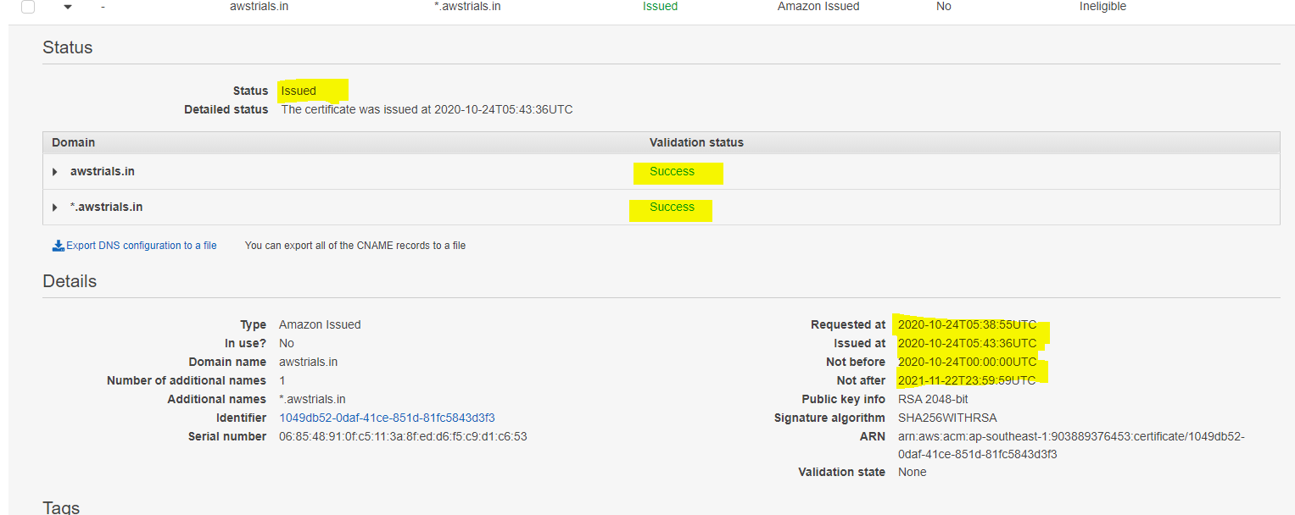

**Step#3. Service RDS –Relational Data Services -**

Create Databases – 2 Nos, Dev, Prod

Database : MySQL - Free tier

RDS- Data Base Service

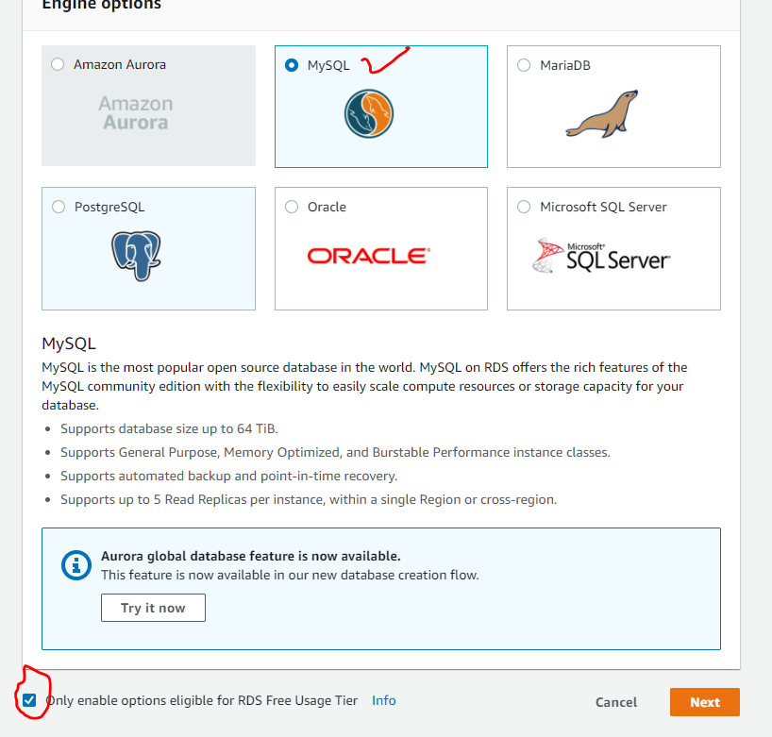

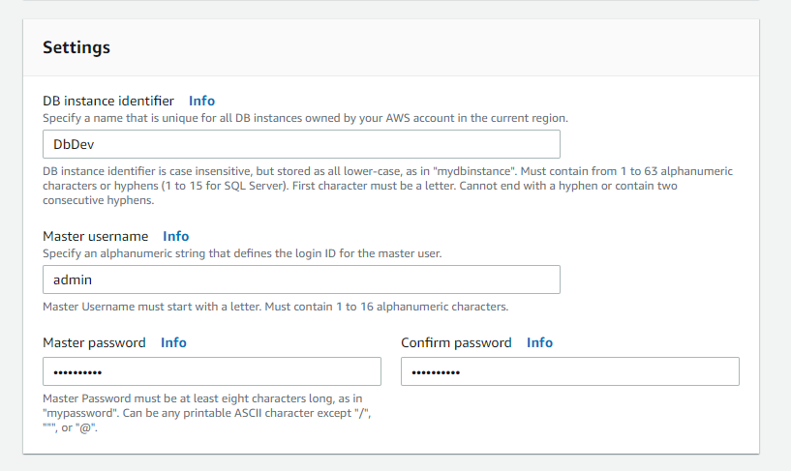

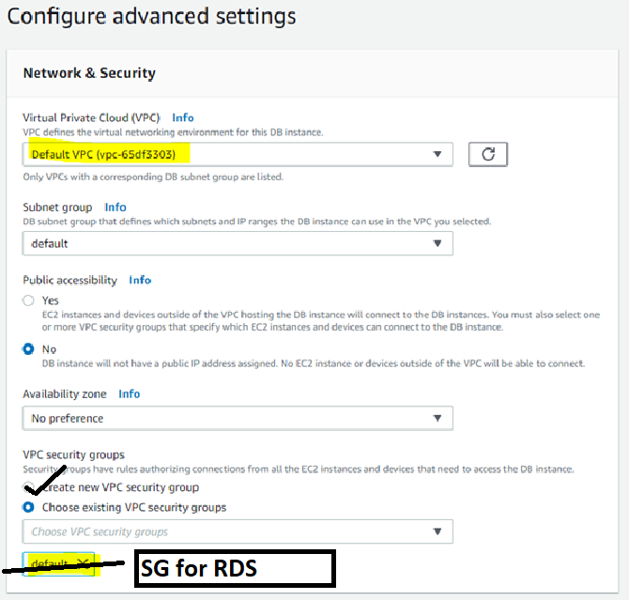

Security Group Created – SG for RDS – with 3306 port

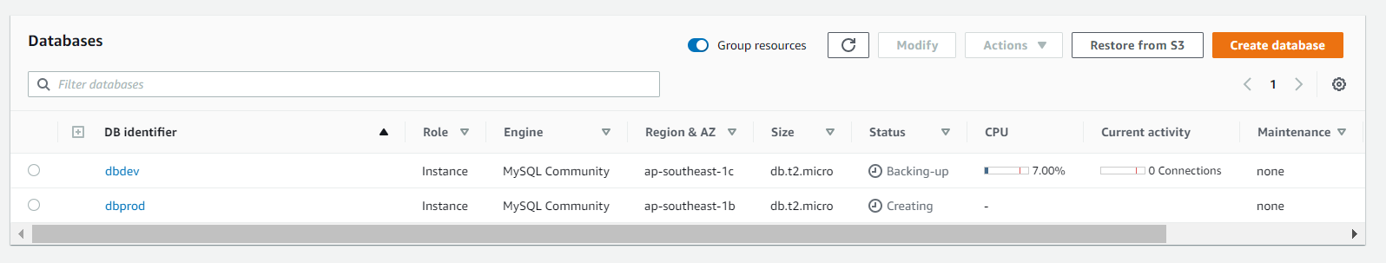

**Step#4. EC2 instances created**

EC2 Instances

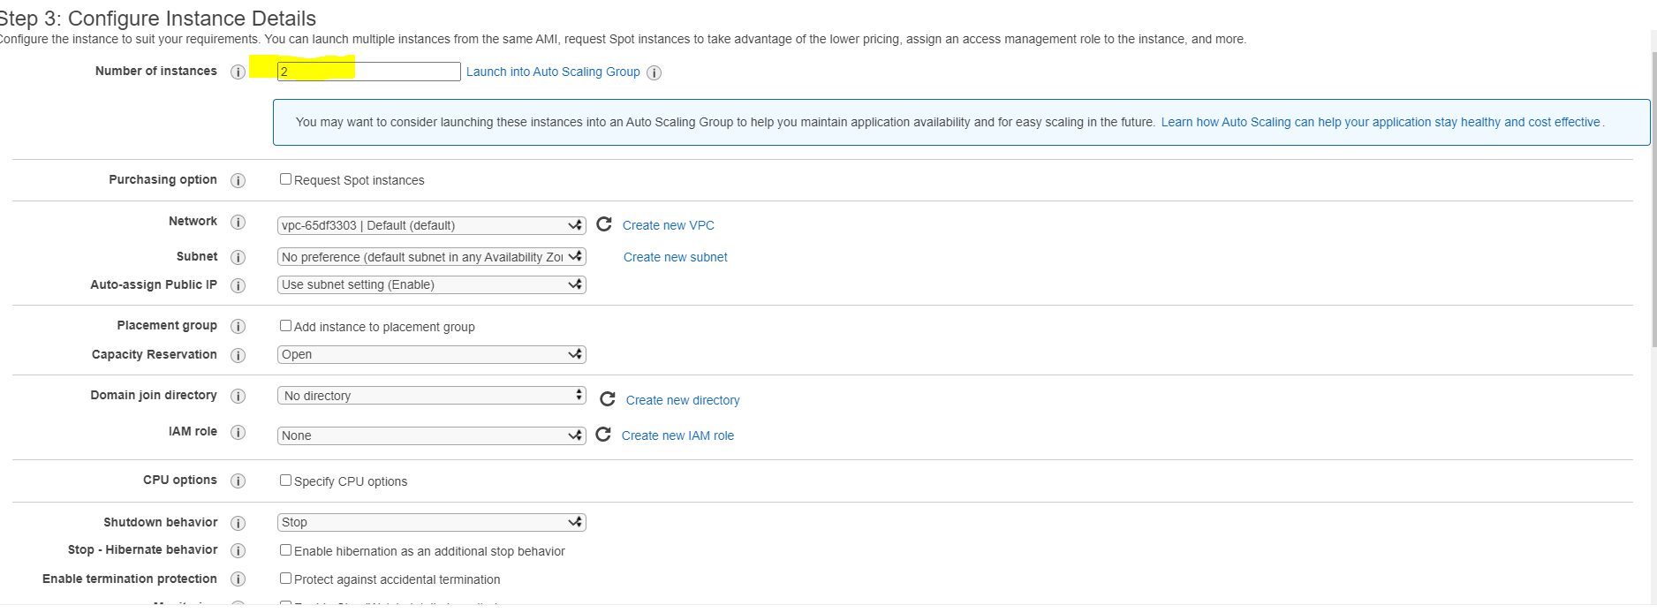

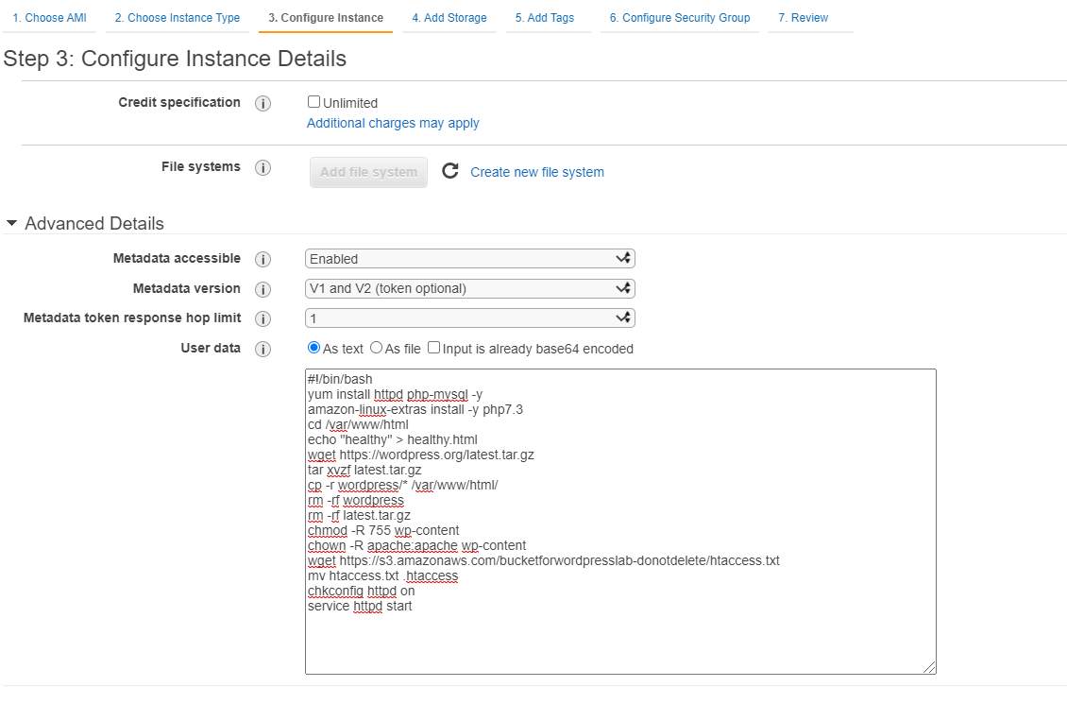

Security Group – SG for RDS – with 3306 port

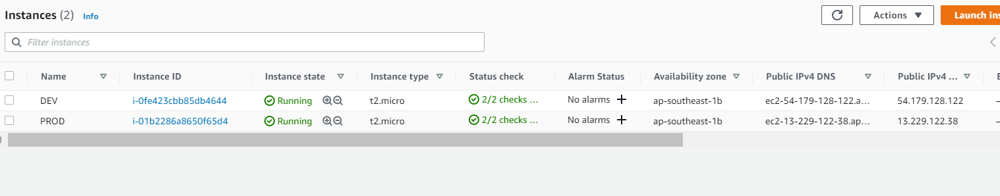

Select DEV instance with putty

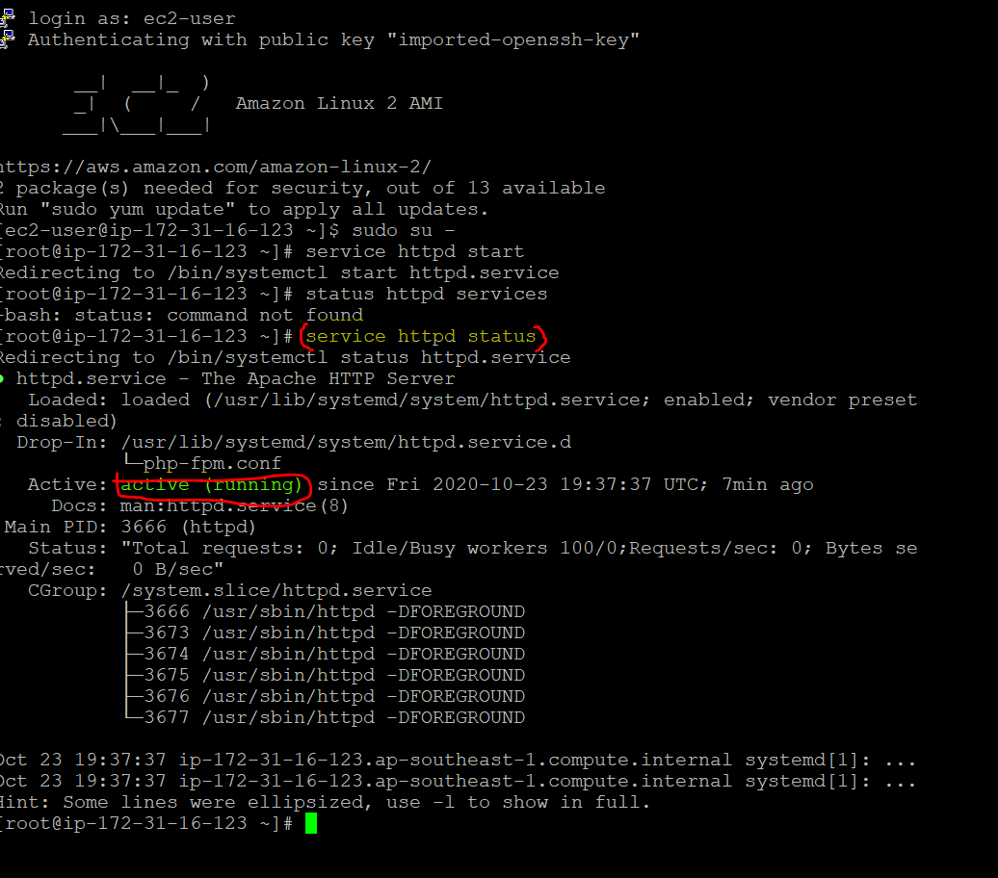se

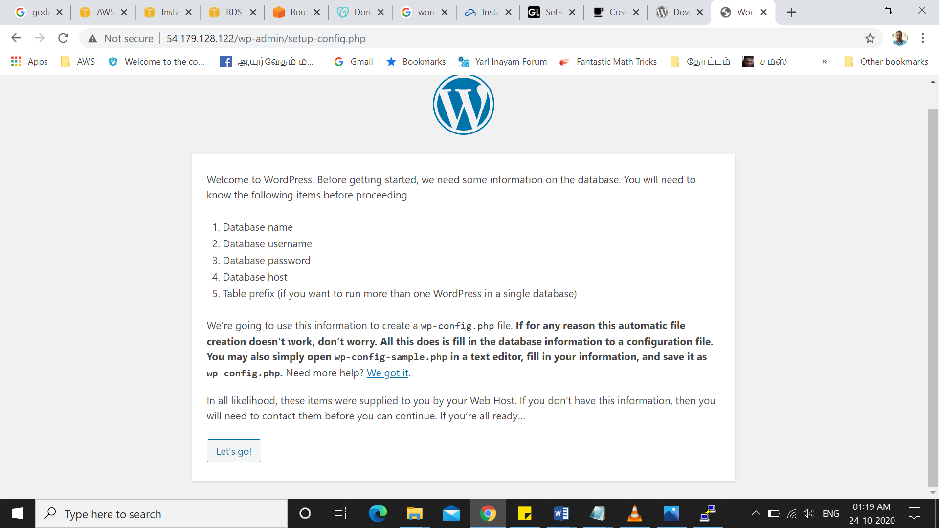

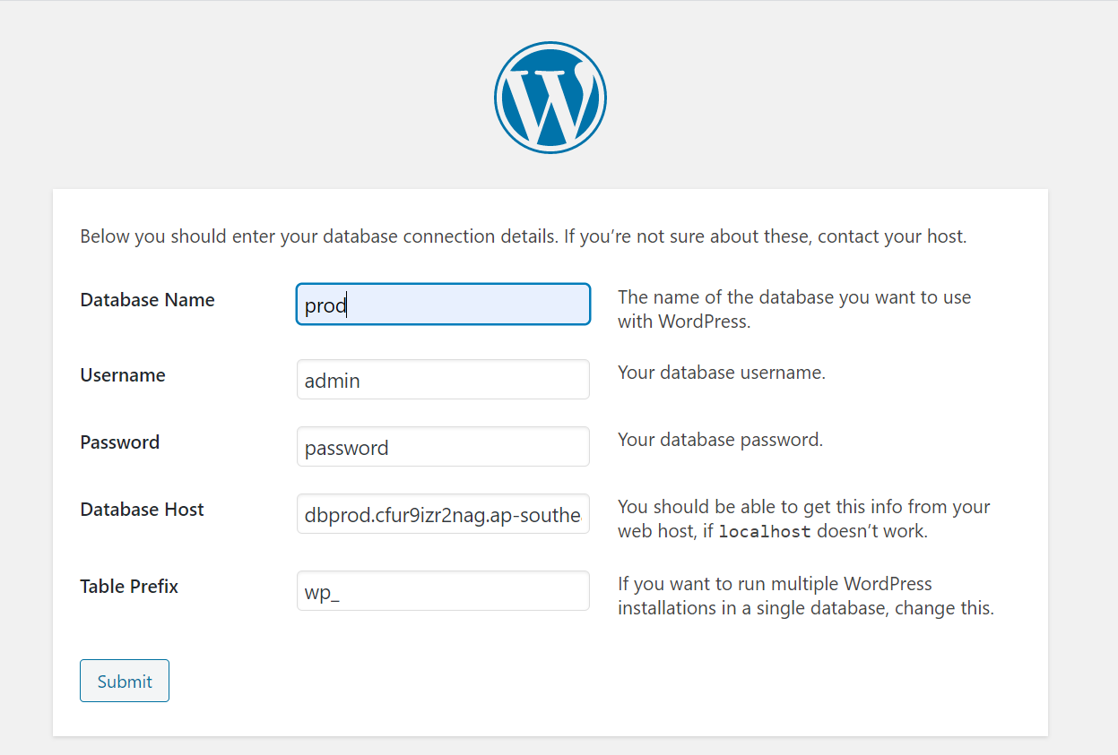

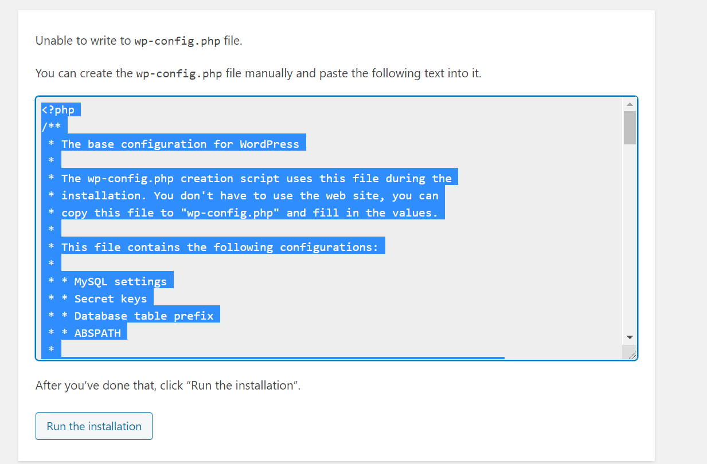

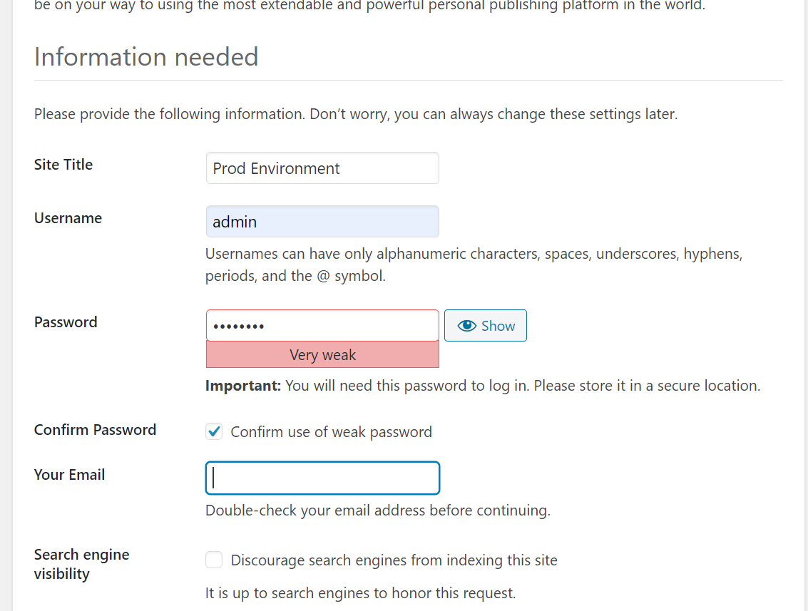

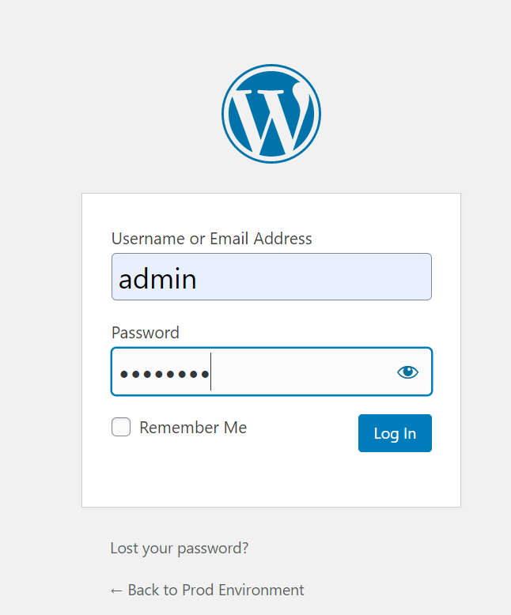

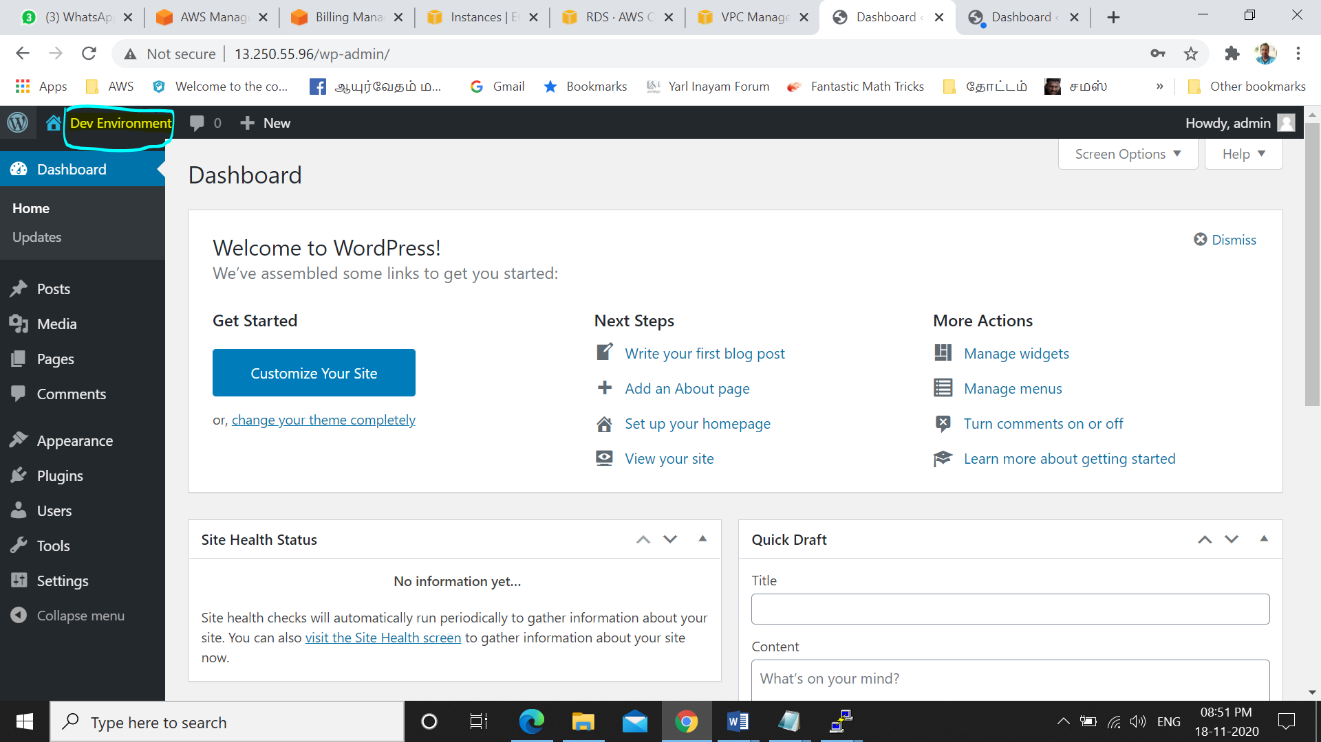

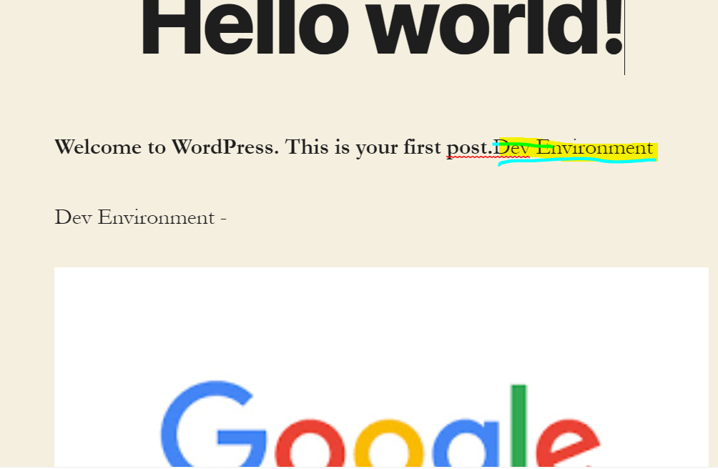

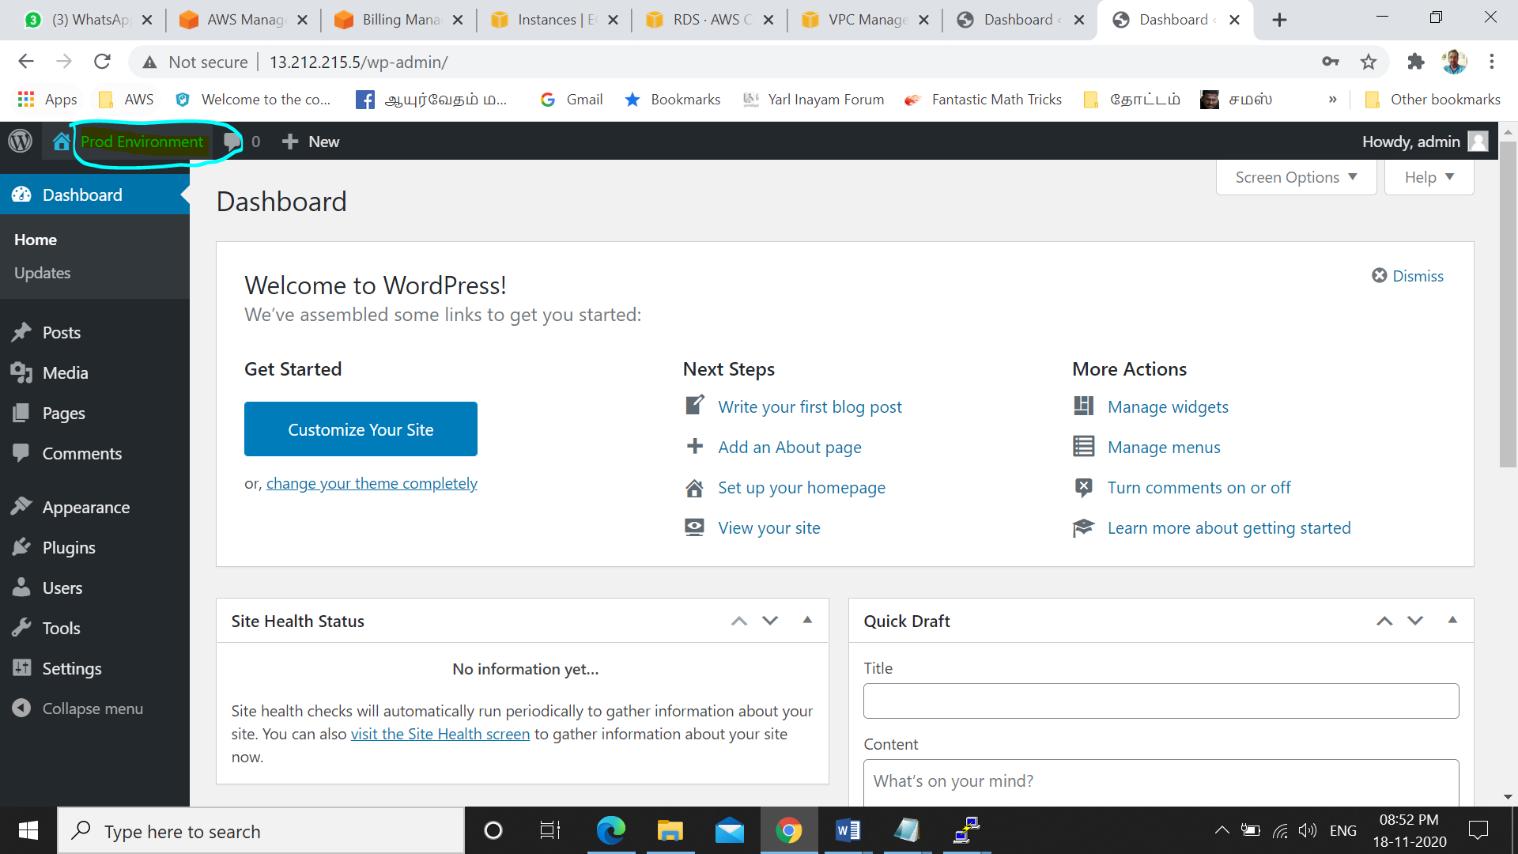

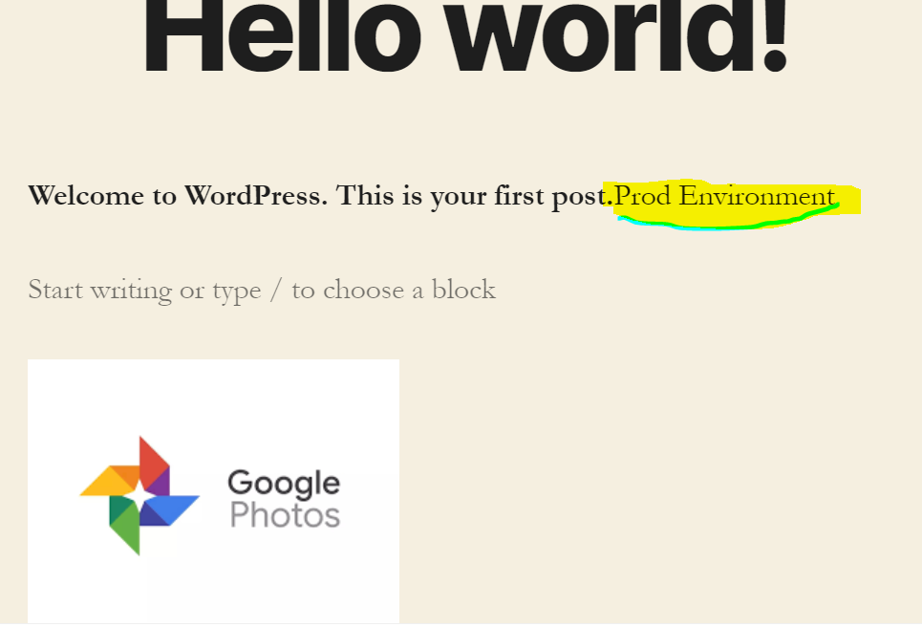

**Step#5. Load Balancer**

Create load balancer:-Classic Load Balancer

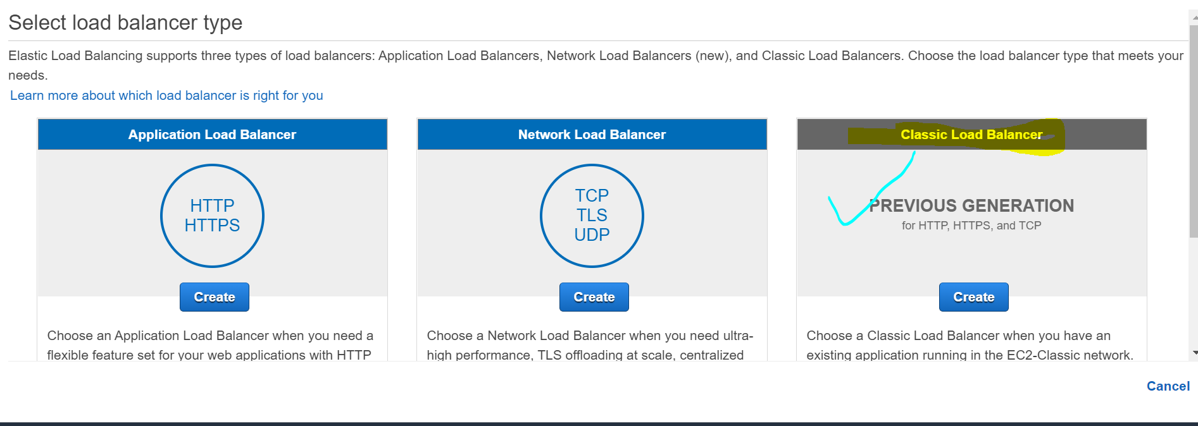

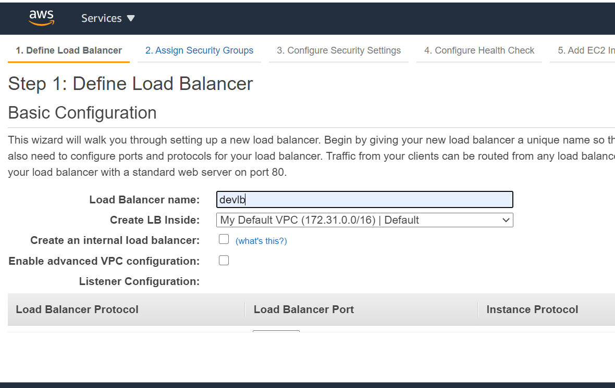

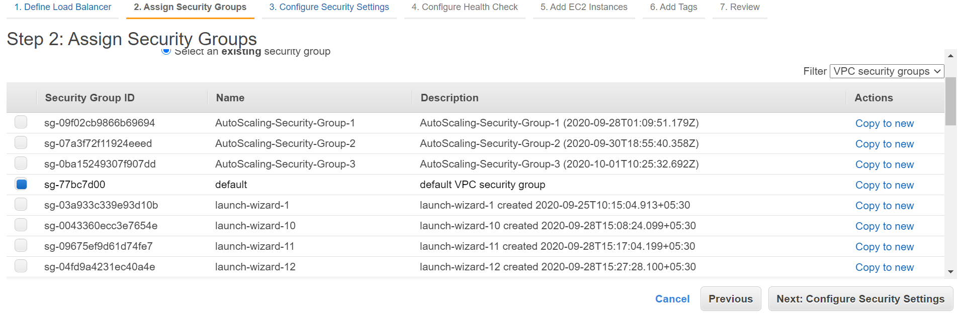

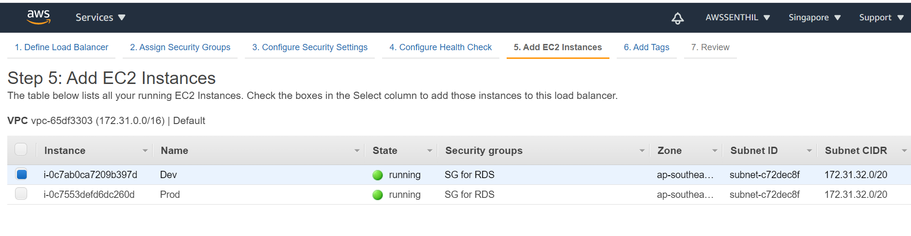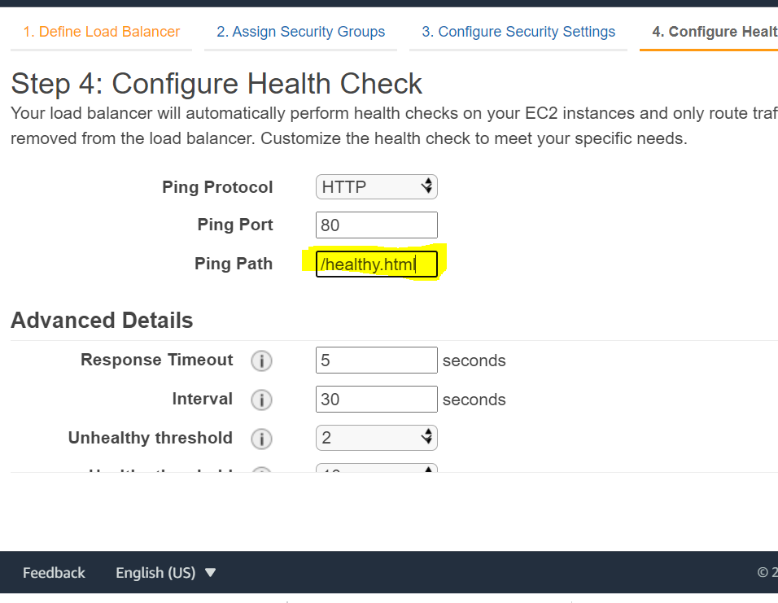



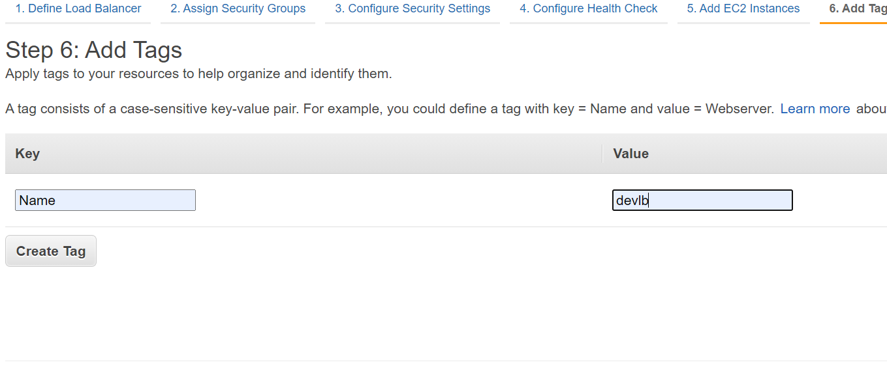 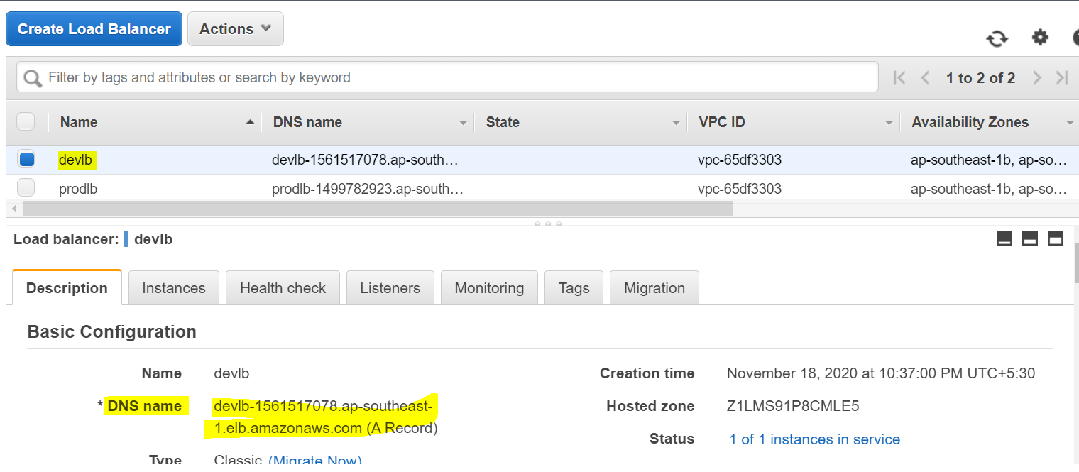

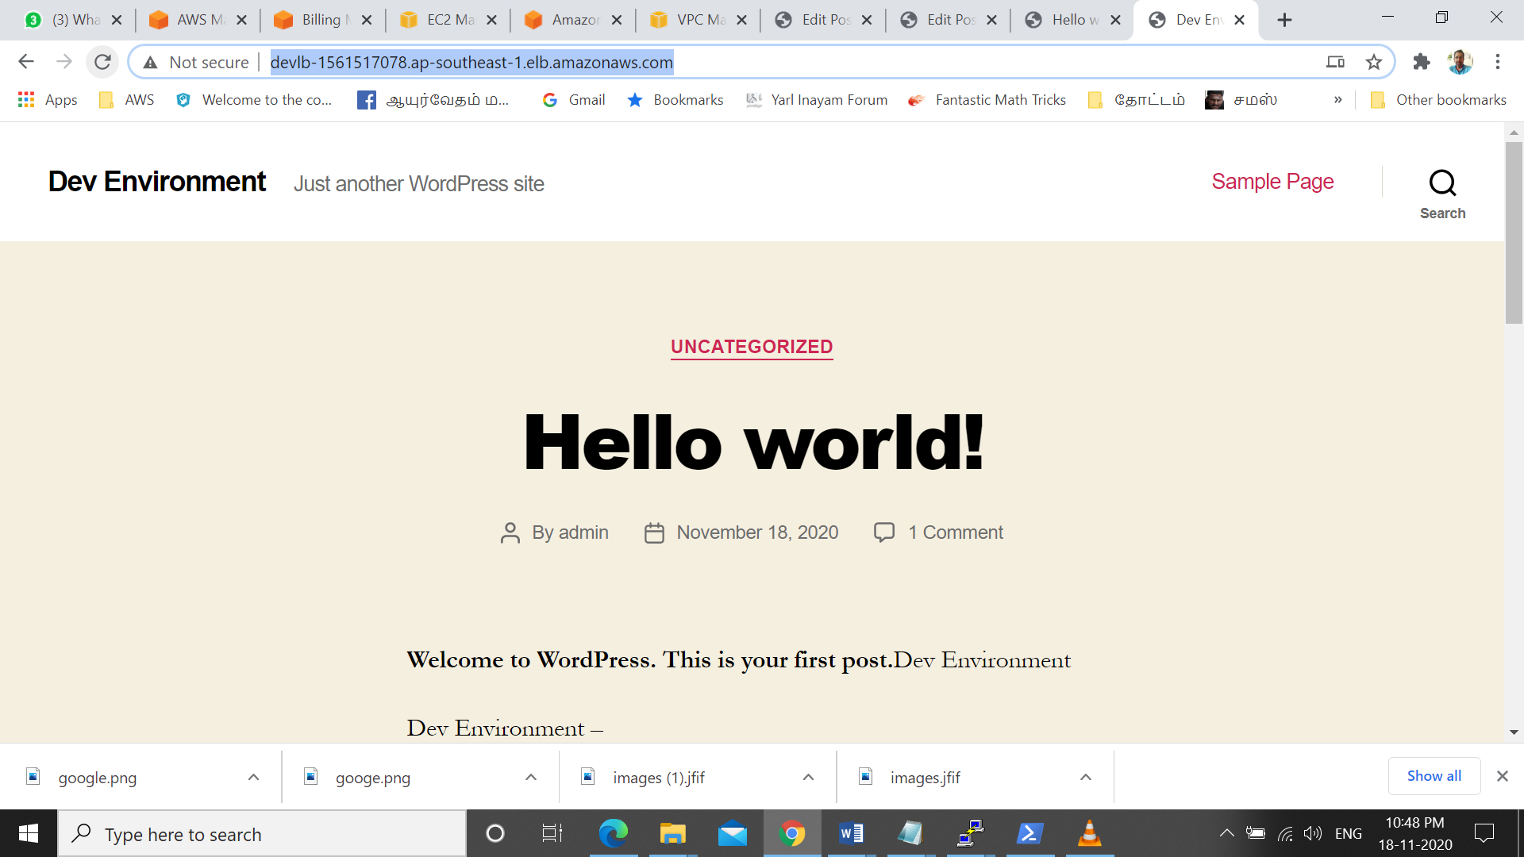

**Step#6. Domain Based Routing**

Route53🡪 Recordset

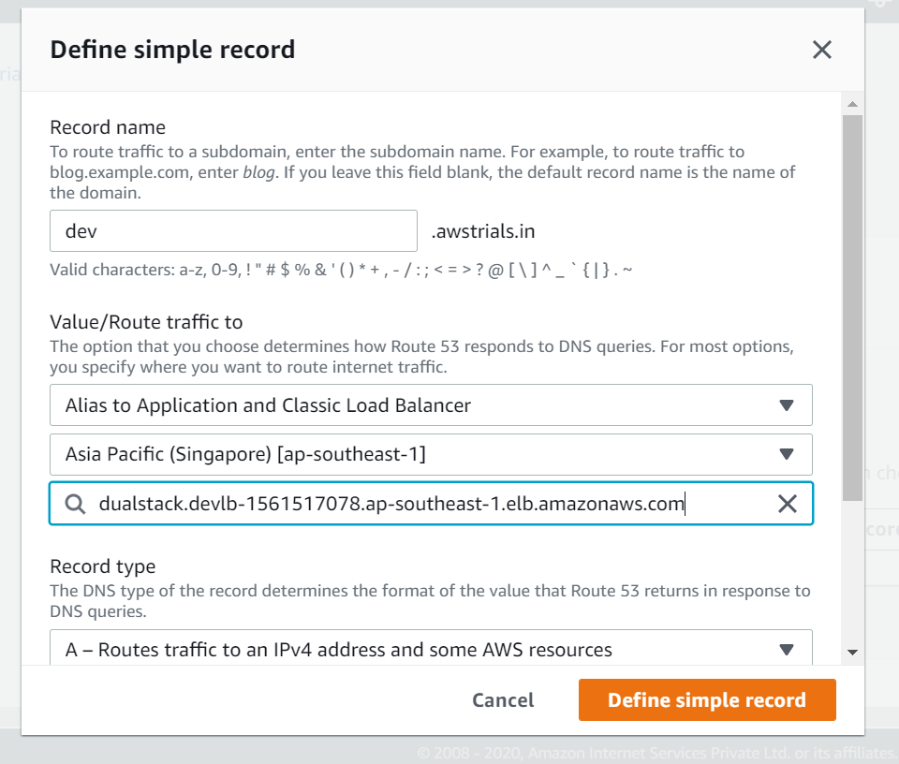

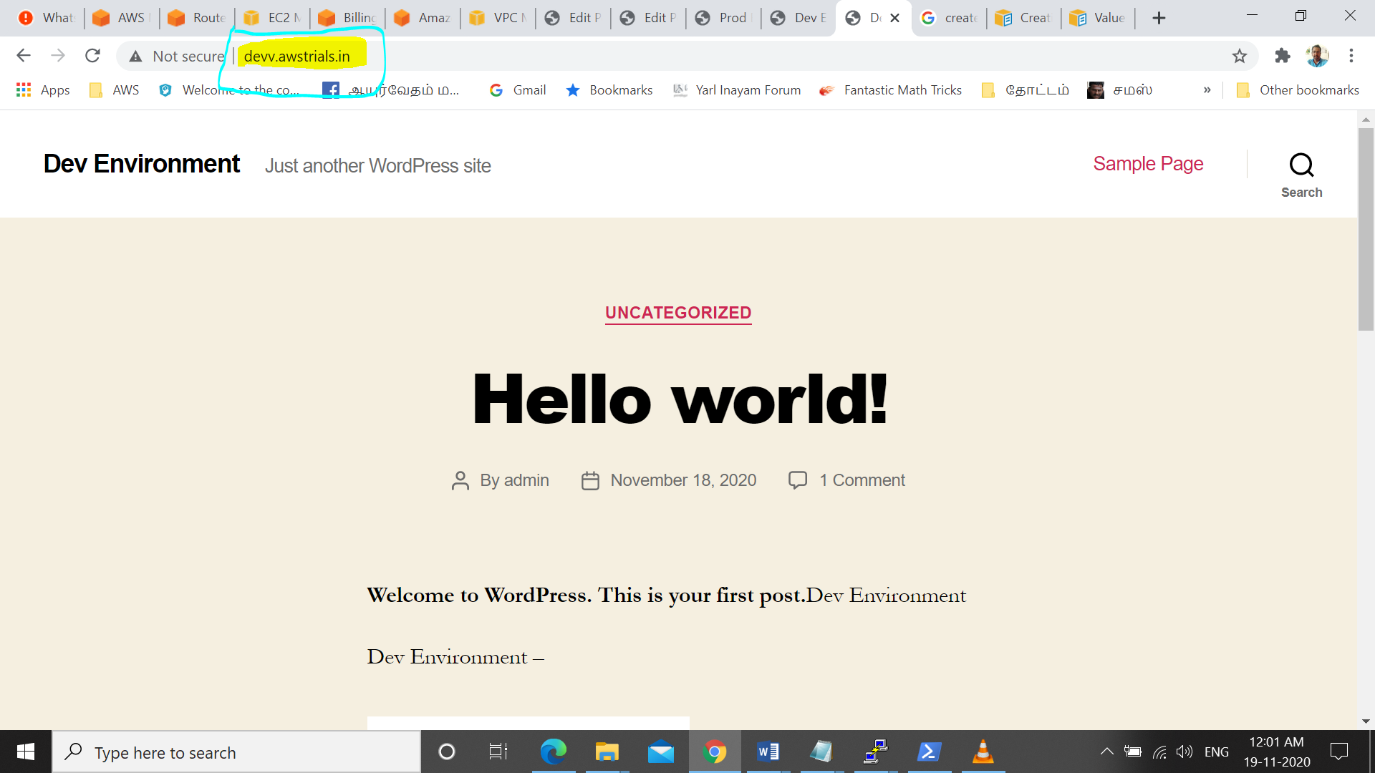

**Step #7 : Sync Dev and Prod via S3**

**Dev(db) 🡪 devlb 🡪 instance 🡪S3(webserver)**

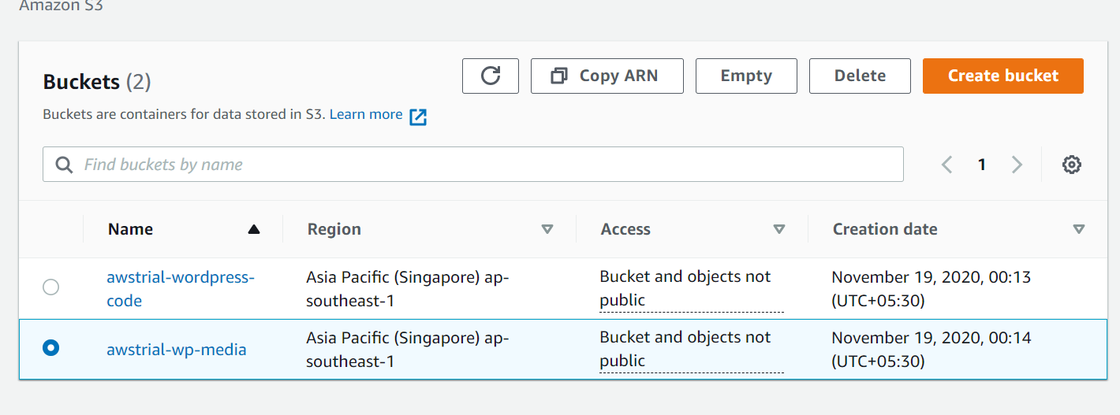

Create S3 Buckets.

Crone Job in Linux

Crone – daemon is a built in linux utility  
-runs the process on scheduled time  
-runs in background

-

awstrial-wp-media

awstrial-wordpress-code

**Dev – Ec2 intance   
//\*** Crone codes for dev & prod.

*/5 * * * * aws s3 sync --**delete** /var/www/html/wp-content/uploads s3://awstrial-wp-media(Directory)

*/5 * * * * aws s3 sync --delete /var/www/html/ s3://awstrial-wordpress-code

****** **The File from Given Path is copied to given S3 Path \*\*\*\*\*\***

**Prod**

*/3 * * * * aws s3 sync --delete s3://awstrial-wp-media /var/www/html/wp-content/uploads

*/3 * * * * aws s3 sync --delete s3://awstrial-wordpress-code /var/www/html/

****** **The File from S3 Path is copied to given Given Path (webserver)\*\*\*\*\*\***

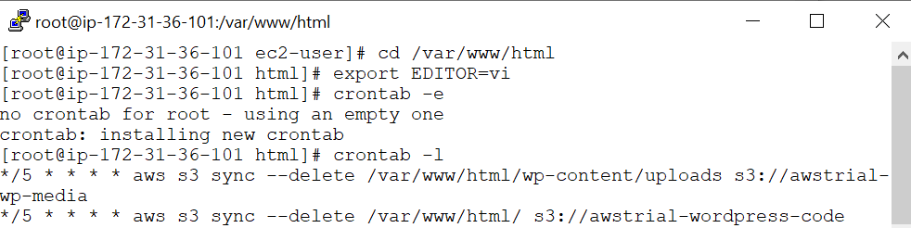

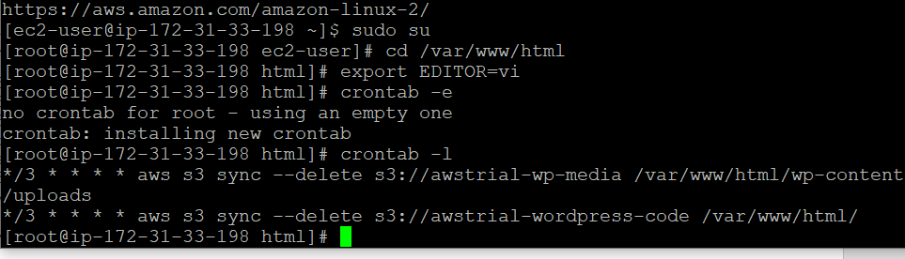

**Step #8 :IAM Roles**

To connect ec2- s3

Create role to access ec2 – to – s3- administration rights to ec2

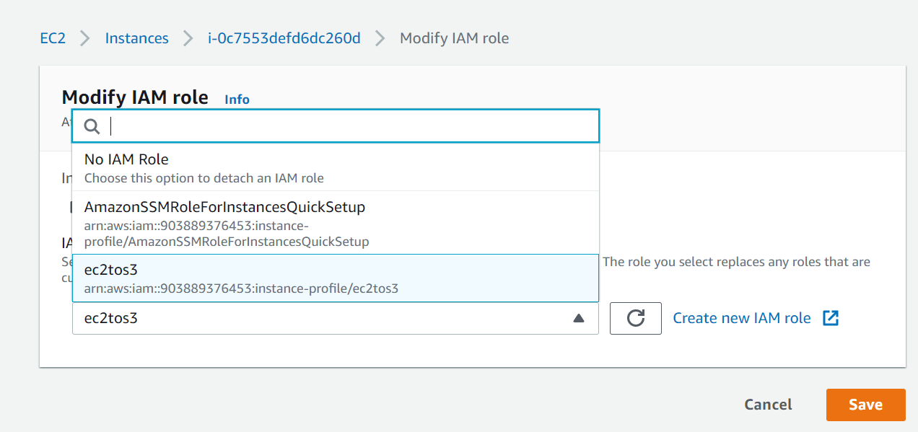

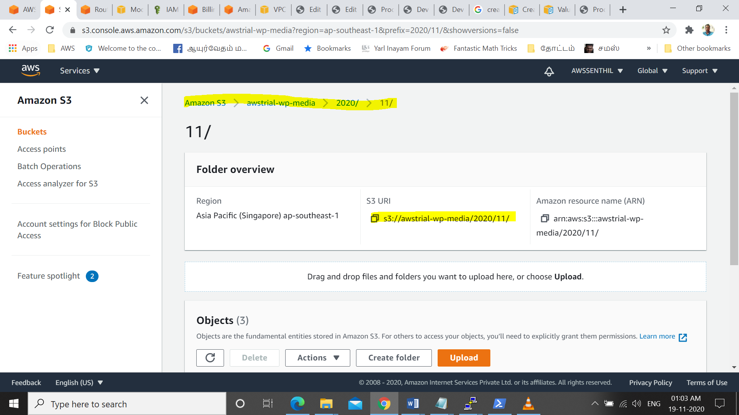

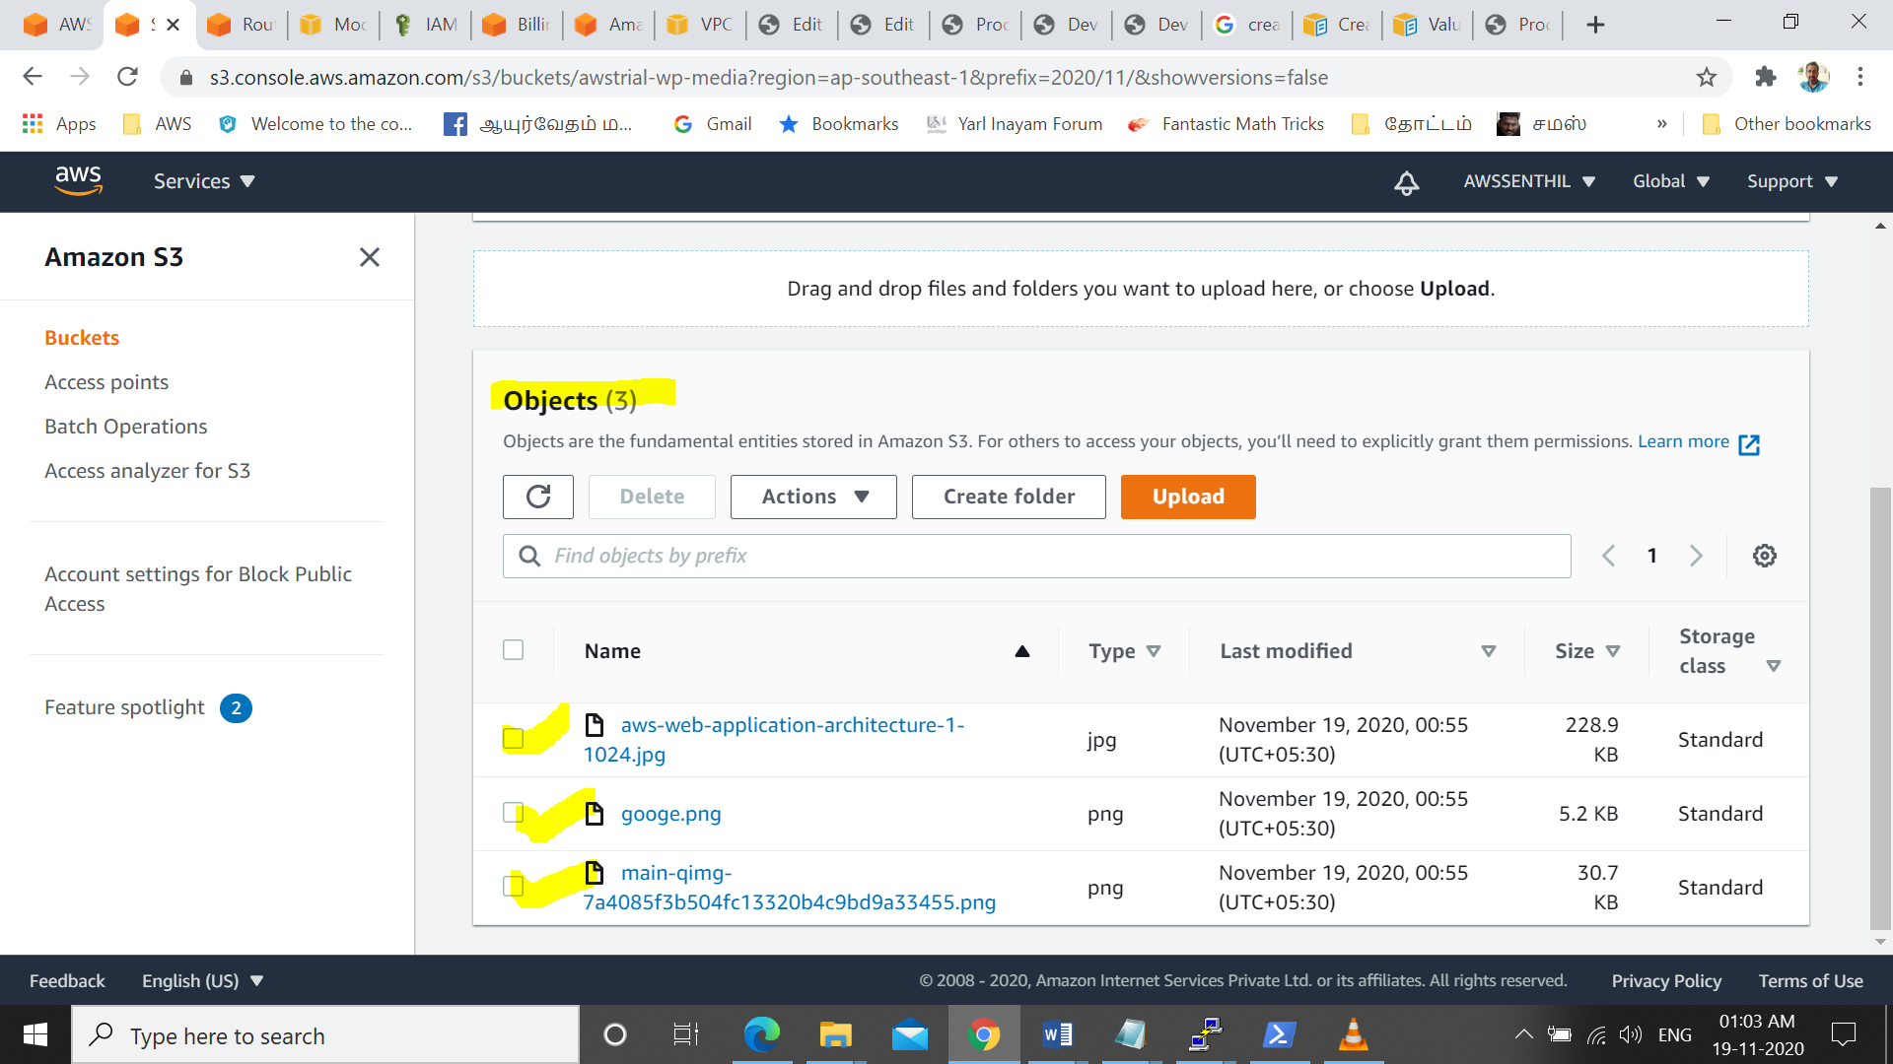

Step #9 Certificate Purchase

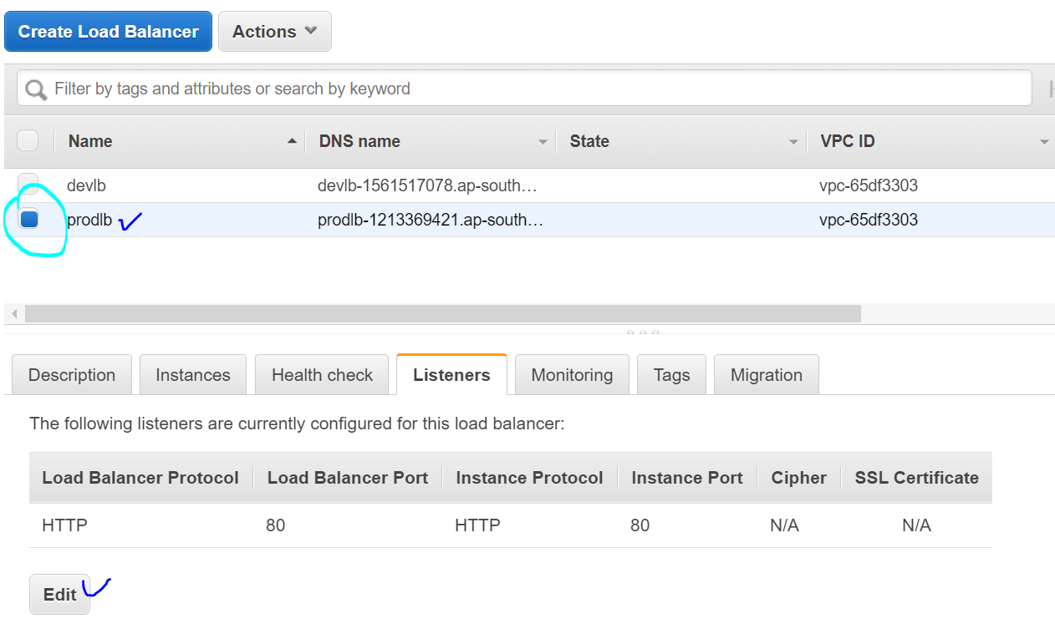 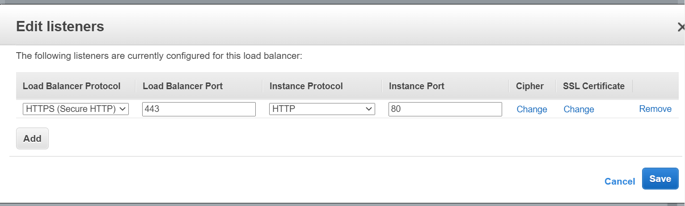

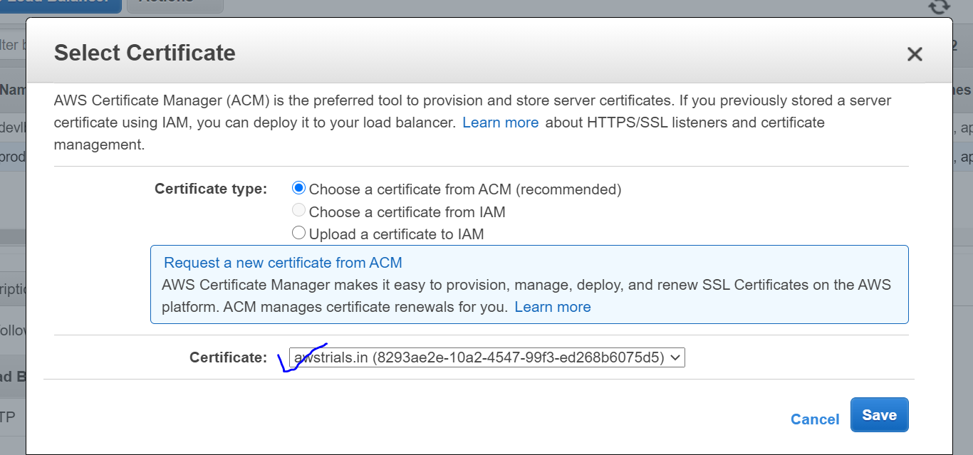

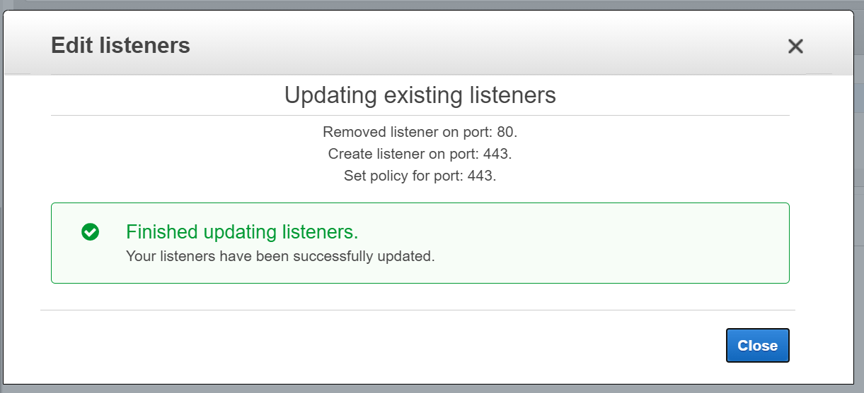

**Step#10 : Create Dashboard in Cloud Watch(Custom Meter)**

**Note : Memory Utilization- Monitor Using Cloud Watch is not a task available in AWS.**

**We should customize to create .**

**AWS-Cloud Watch 🡪 Metrices**

[**https://docs.aws.amazon.com/AWSEC2/latest/UserGuide/mon-scripts.html**](https://docs.aws.amazon.com/AWSEC2/latest/UserGuide/mon-scripts.html)

With some versions of Linux, you must install additional Perl modules before you can use the monitoring scripts.

**To install the required packages on Amazon Linux 2 and Amazon Linux AMI**

**sudo yum install –y perl-Switch perl-DateTime perl-Sys-Syslog perl-LWP-Protocol-https perl-Digest-SHA.x86_64**

sudo yum install perl-Switch perl-DateTime perl-Sys-Syslog perl-LWP-Protocol-https perl-Digest-SHA --enablerepo="rhui-REGION-rhel-server-optional" -y

sudo yum install zip unzip

**Monitoring Scipts :**

**To download, install, and configure the monitoring scripts**

1. At a command prompt, move to a folder where you want to store the monitoring scripts and run the following command to download them:

curl https://aws-cloudwatch.s3.amazonaws.com/downloads/CloudWatchMonitoringScripts-1.2.2.zip -O

2.un the following commands to install the monitoring scripts you downloaded:

unzip CloudWatchMonitoringScripts-1.2.2.zip && \

rm CloudWatchMonitoringScripts-1.2.2.zip && \

cd aws-scripts-mon

The following example collects all available memory metrics and sends them to CloudWatch, counting cache and buffer memory as used

./mon-put-instance-data.pl --mem-used-incl-cache-buff --mem-util --mem-used --mem-avail

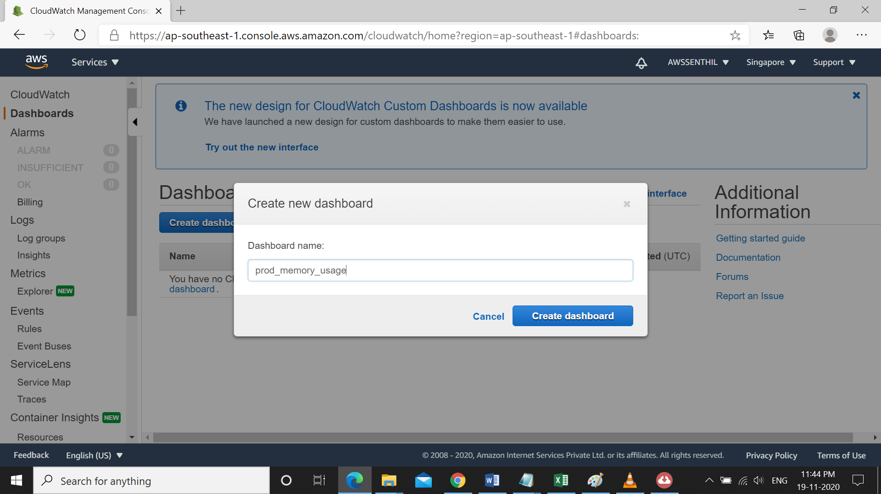

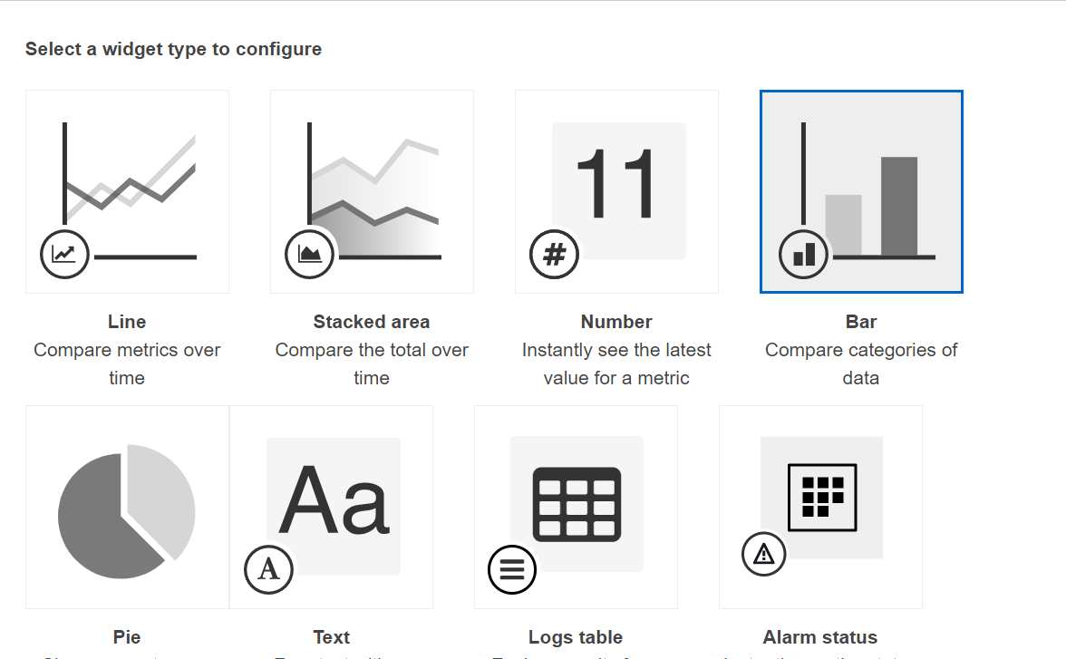

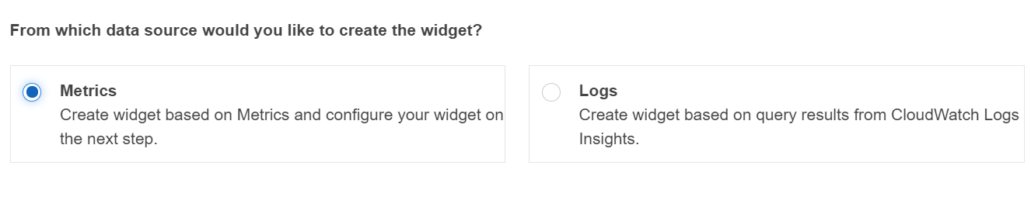

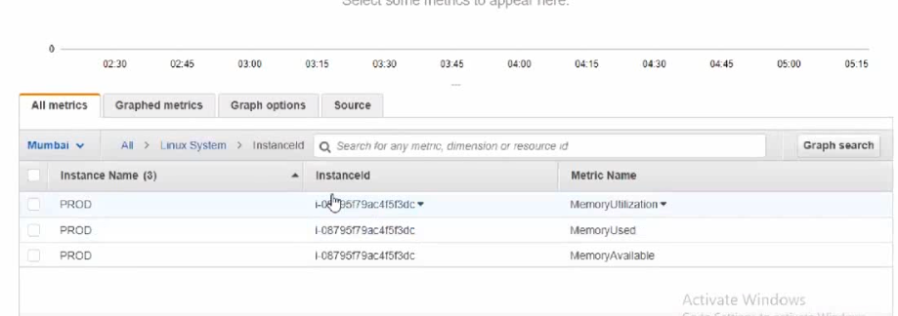

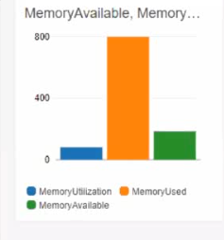

Step # 11, **The End Client / User Should Access the website only using https not with http.**

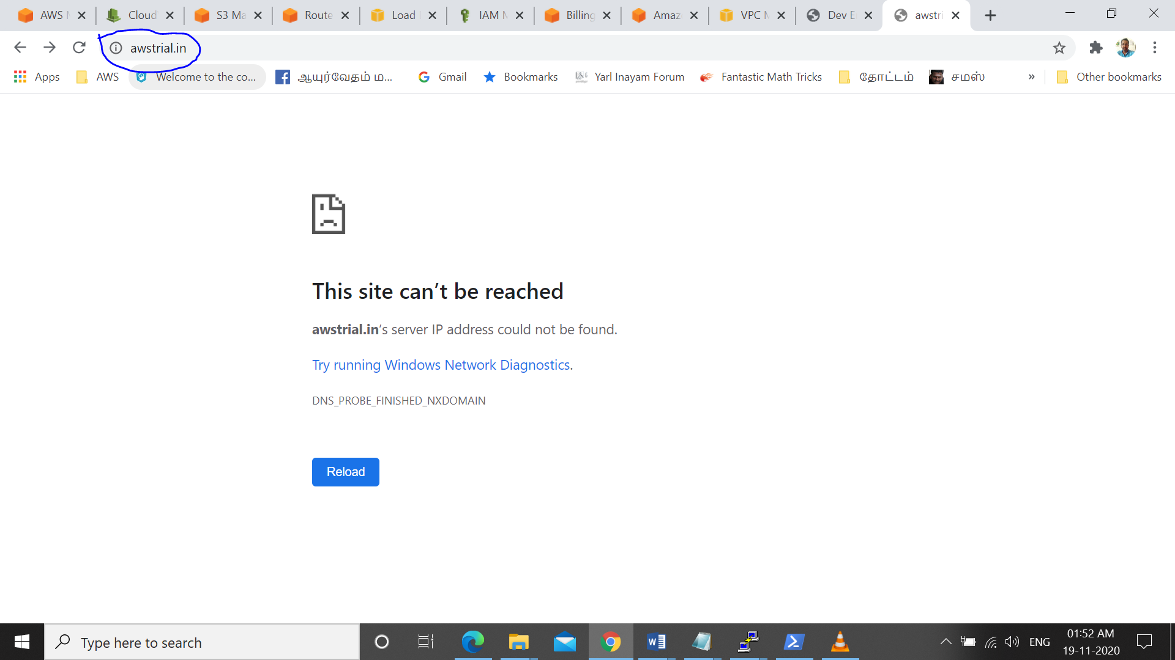

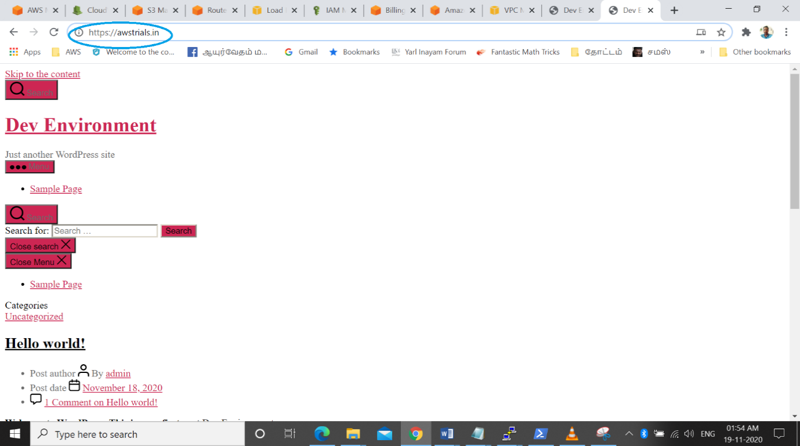

**AWS PROJECT – REAL TIME PROJECT   
Create and Install Wordpress in AWS EC2 with RDS  
  
Scope of the Project:** **(Project with Default VPC)**

#**1. Sync Dev & Prod Databases via S3 Service**

**#2. Domain Based Routing**

**#3. The End Client / User Should Access the website only using https not with http.**

**#4. Create Dashboard in Cloud Watch (Custom Meter)**

**#5. Memory Utilization- Monitor Using Cloud Watch**

**#6. Purchase and implement Certification for the Domain**

**Services We Used :**

**1 . Route53 - – DNS Connectivity with Domain**

1. **Amazon Certificate Manager (ACM) – SSL certificate**
2. **RDS –Relational Data Services - Database Service**
3. **VPC – Security Group, Subnets, Integrate all Services**
4. **EC2 – Instances for subnets**
5. **ELB – Load balancer to manage Traffic.Cerificate issue**
6. **S3 – Simple storage Service – for file storage and retrieve**
7. **IAM – Service to Service Roles Connectivity (EC2-S3)**
8. **Cloud watch-: Memory Utilization- Monitor Using Cloud Watch**

**Project Proceedings:**

**Step#1 . Service ROUTE53 – DNS Connectivity with Domain**

**Step#2 . Service:Amazon Certificate Manager (ACM)**

**Step#3. Service: RDS –Relational Data Services -**

**Step#4. Service: EC2 instances created**

**Step#5. Service: Load Balancer**

**Step#6. Domain Based Routing**

**Step #7 : Sync Dev and Prod via S3**

**Step #8 : IAM Roles(EC2 to S3)**

**Step #9:** **Certificate Purchase**

**Step#10 : Create Dashboard in Cloud Watch(Custom Meter)**

Step # 11, :**The End Client / User Should Access the website only using https not with http.**